**ADS Assignment 1:**

Problem 5 :

**Dry Run & Analyze: Time and Space Complexity**

1. Dry run the code for n = 4. How many times is * printed?

What is the time complexity?

void printTriangle(int n) {

for (int i = 0; i < n; i++)

for (int j = 0; j <= i; j++)

System.out.print("*");

}

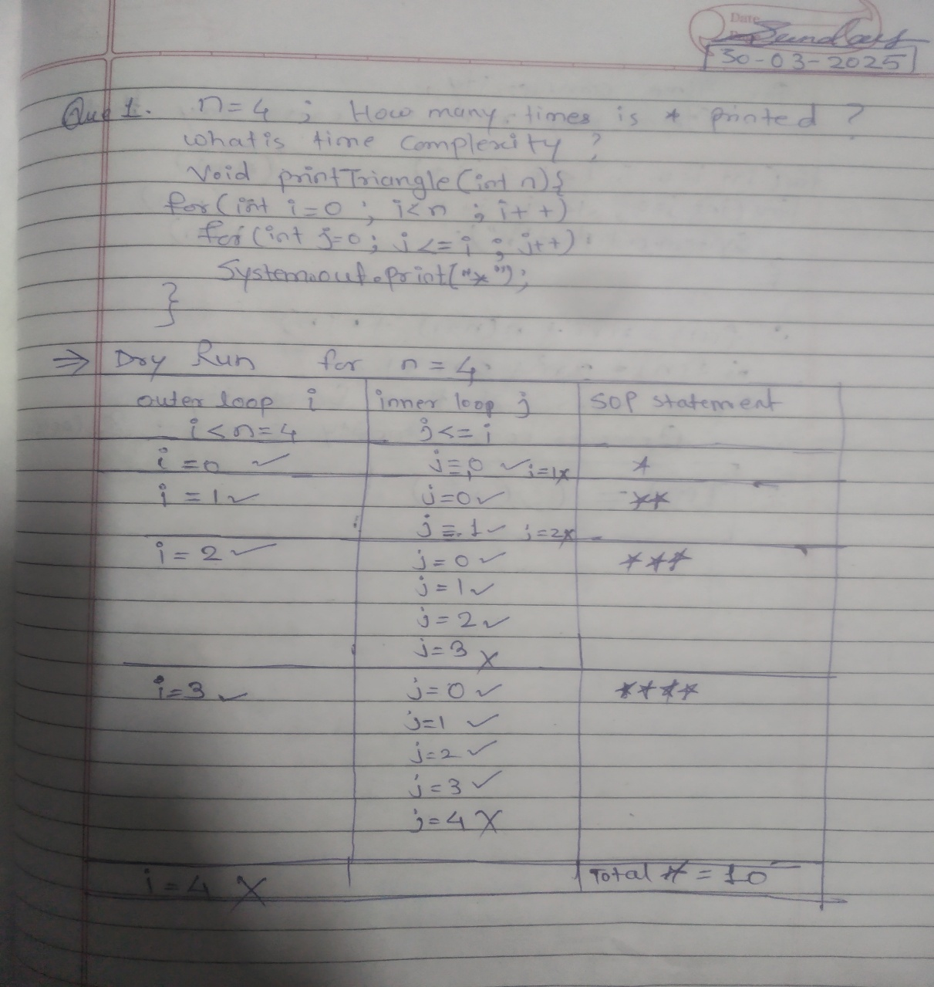

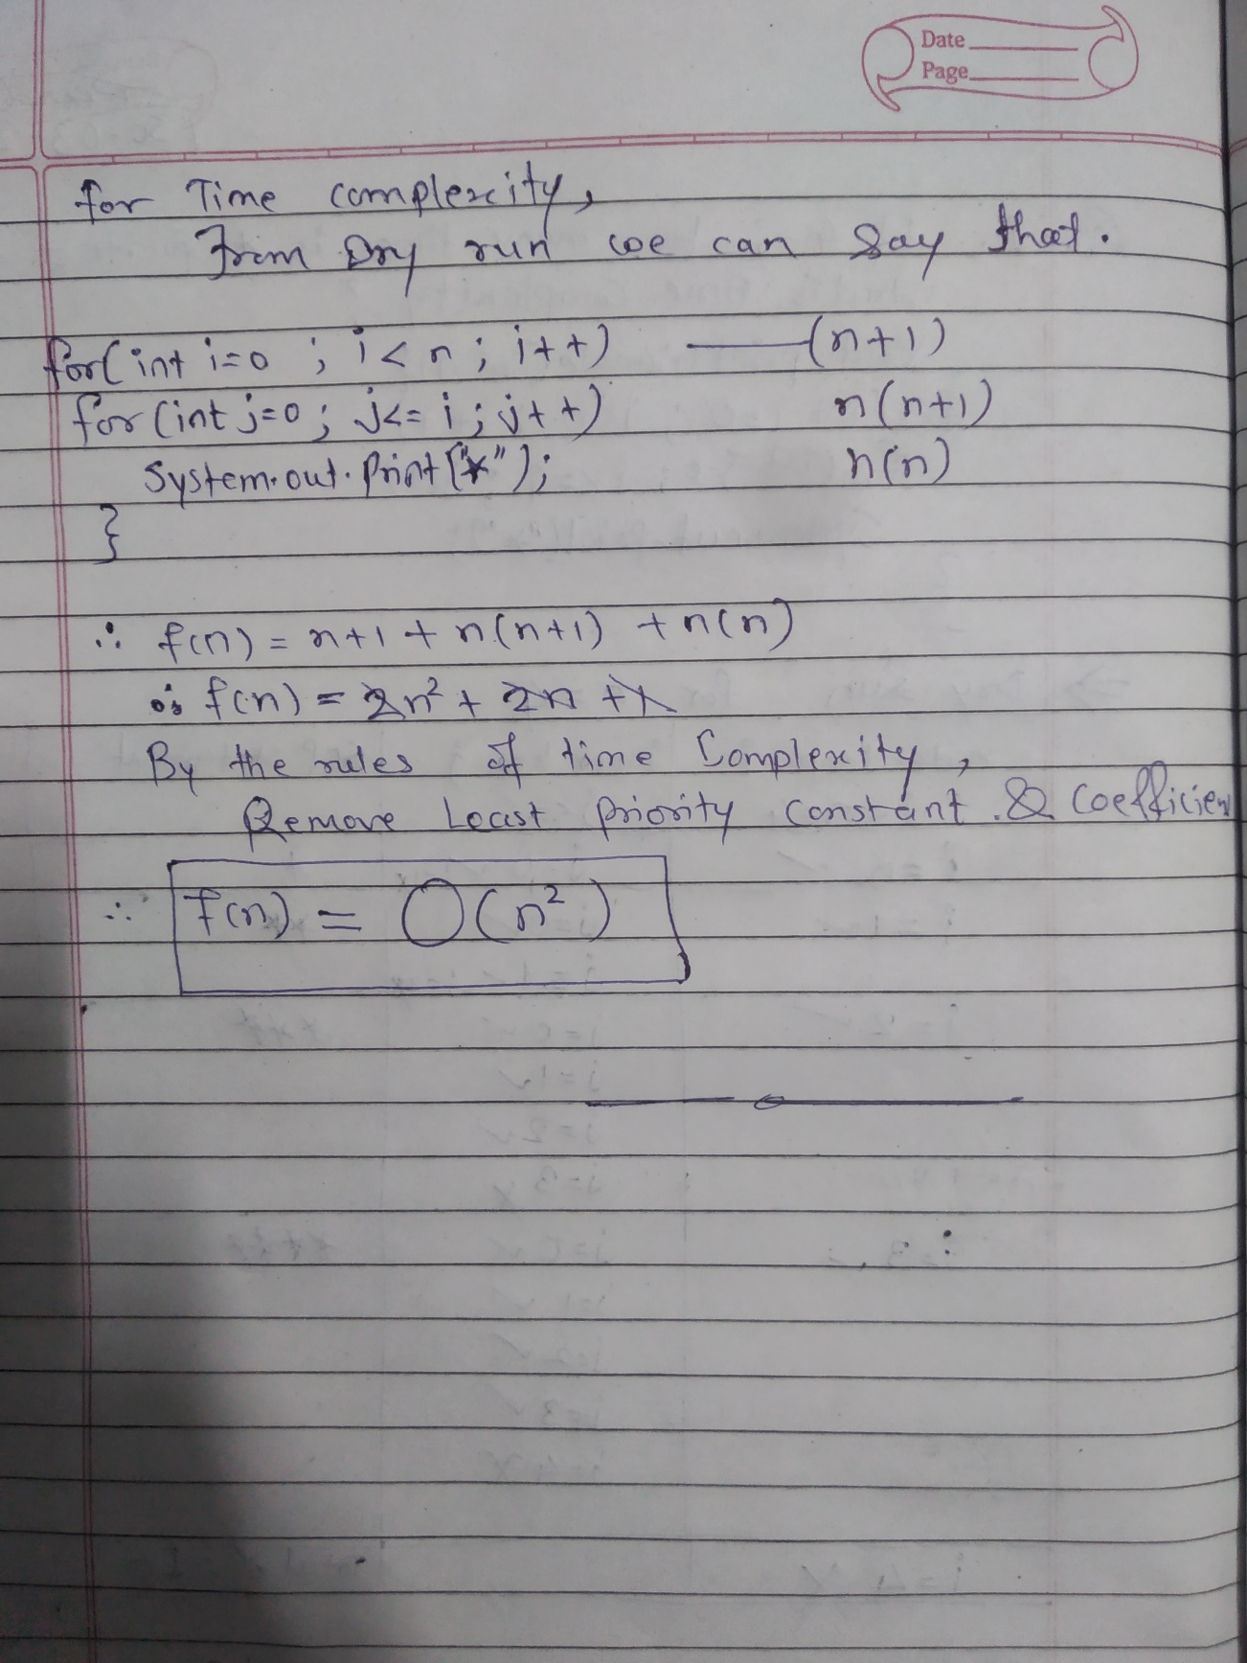

1. **Dry run for n = 8.** 